**STÉPHANE DÍAZ-ALEJO LEÓN**

**Exercise 6.** (*) In the same situation as above use the program SWGraphs to give an answer to the following questions:

(a) A traveler wants to go from Sant Celoni to L’Escala. It does not matter the number of kilometers, but he wants to go through the fewest possible number of tolls. Find a route with this condition.

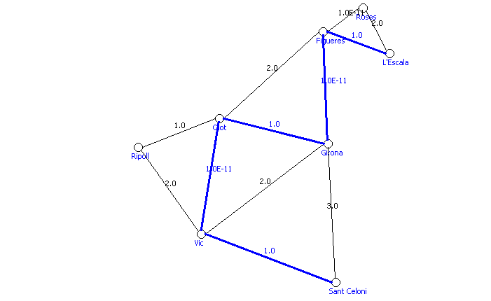

(b) The same traveler wants to go from Sant Celoni to L’Escala so that the money that he spends in gas and tolls is the lowest possible. Taking into account that his car spends six liters of gas per 100 kilometers, that one liter of gas costs 1.5 euros and that in each toll he must pay 3 euros, compute the most economical route. 